**Catani VGravity Manual**

**Link:** [**https://github.com/Ameer-Mushani/VGravity**](https://github.com/Ameer-Mushani/VGravity)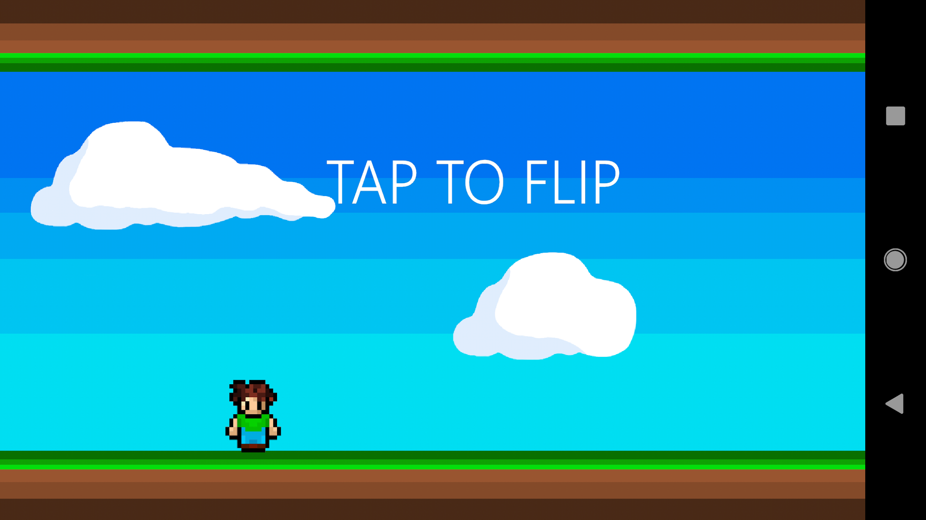

# How to play:

Tap the screen to flip gravity! Avoid obstacles that fly at you, try to survive as long as possible and collect coins!

Find our project at [**https://github.com/Ameer-Mushani/VGravity**](https://github.com/Ameer-Mushani/VGravity)